**Supplementary Figures**

This file contains:

**Supplementary Figure 1:** Richness vs. gene copy number for all compartments

Supplementary Figure 2: Evenness vs. gene copy number for all compartments

Supplementary Figures 3-5: Richness vs gene copy number for (3) mucus, (4) tissue, (5) skeleton.

**Supplementary Figures 6-8**: Evenness vs. gene copy number for (6) mucus, (7) tissue, (8) skeleton.

**Supplementary Figures 9-14**. Relative abundance of microbial classes in (9) mucus, (10) tissue, and (11) skeleton samples sorted by TLR copy number or IL-1R copy number (12,13,14).

**Supplementary Figure 15**: Comparison of domain copy number within genes and gene copies within genomes.

**Supplementary Figure 16**: Correlated responses of microbial families to TLR and IL-1R gene copy number

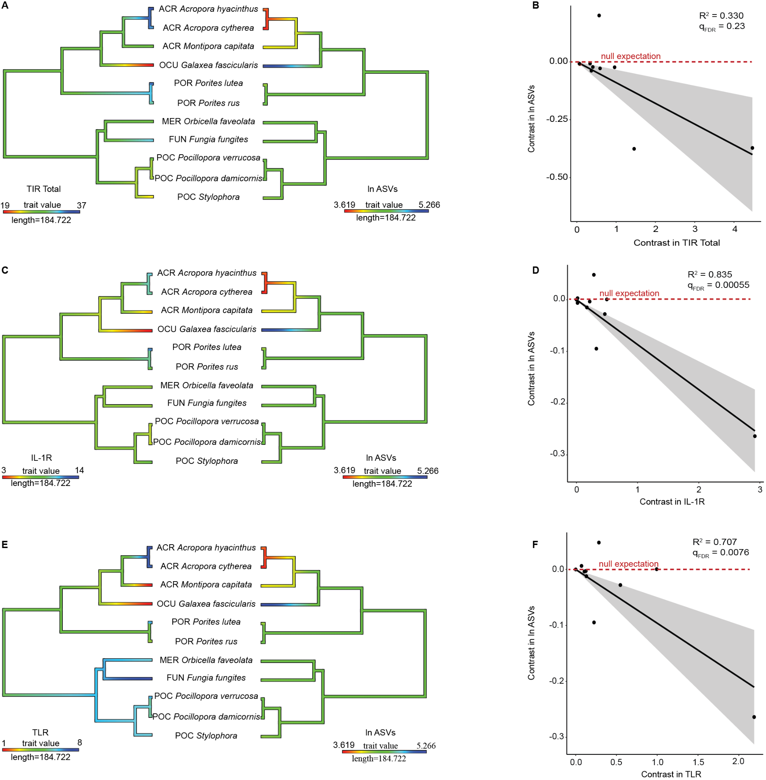

**Fig. S1. Phylogenetic comparison of coral microbiome richness and innate immune repertoire for all compartments combined.** Rows show ancestral state reconstructions (left column) of innate immune gene copy number and microbiome richness, as well as phylogenetic independent contrast analysis for all predicted isoforms (right column) of **A,B** TIR-only genes (R2 =0.330, qFDR= 0.23,p = 0.065); **C,D** IL-1R genes (R2 = 0.834, qFDR= 0.00055, p = 5.14 x 10-5); **E,F** TLR genes (R2 = 0.707, qFDR=0.0076, p = 0.0012) compared against log microbiome richness (ln ASVs). Shading in phylogenetic independent contrasts analysis indicates the 95% confidence interval of the mean.

**2**

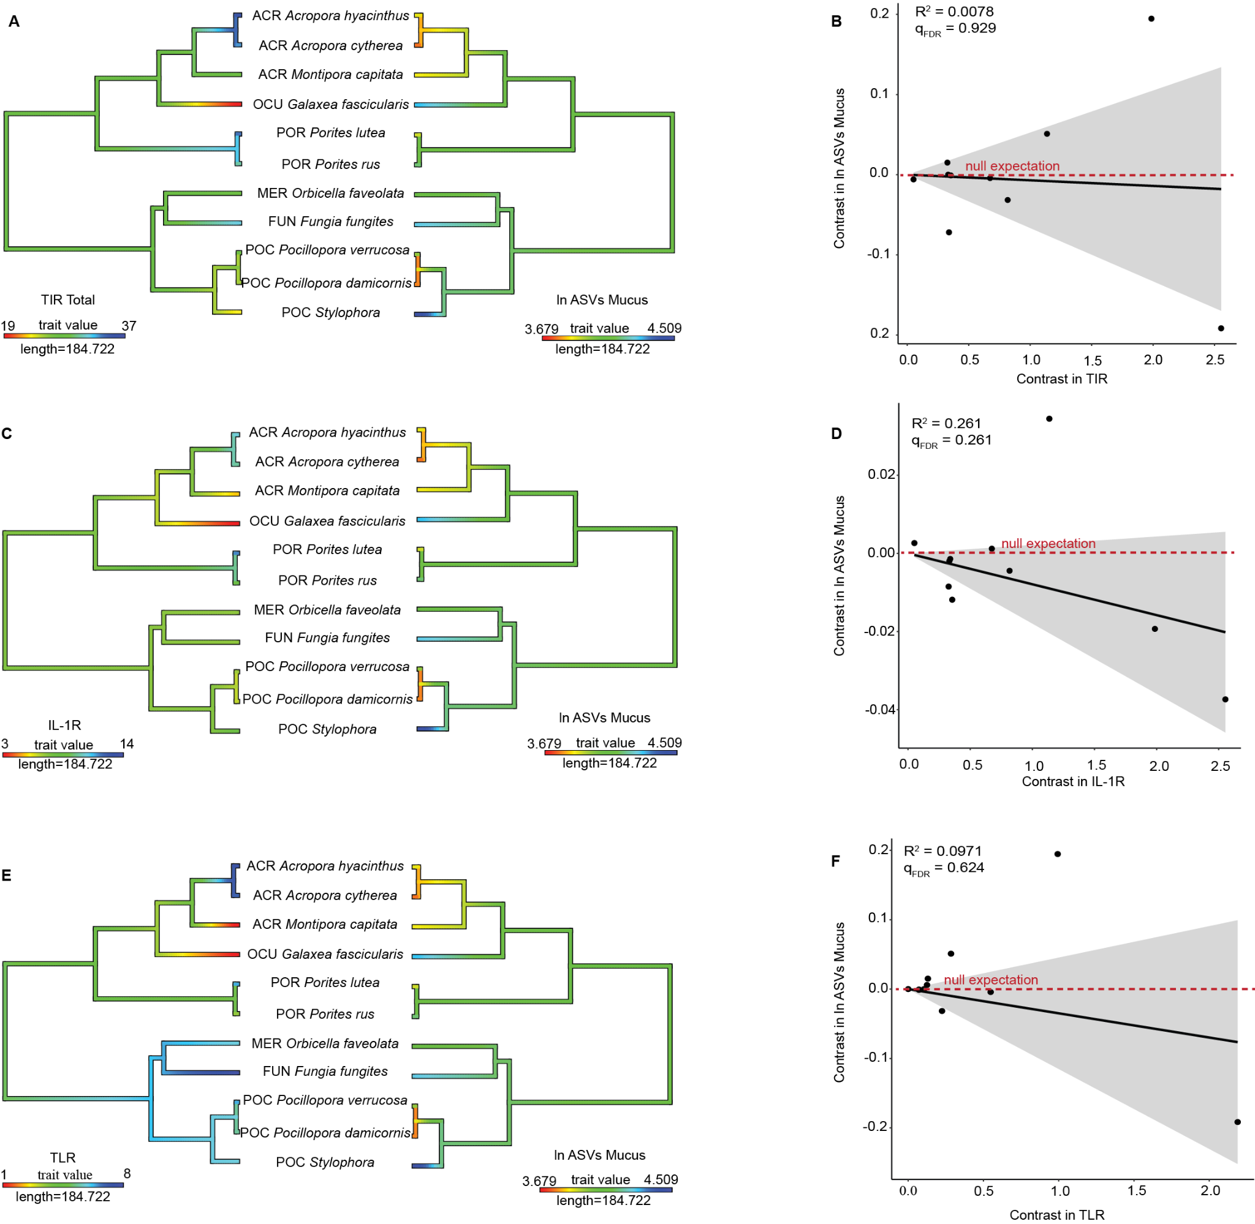

**Fig. S3. Phylogenetic comparison of coral microbiome richness and innate immune repertoire for the mucus compartment.** Rows show ancestral state reconstructions (left column) of innate immune gene copy number and microbiome richness, as well as phylogenetic independent contrast analysis for all predicted isoforms (right column) of **A,B** TIR-only genes (R2 =0.0078, qFDR= 0.929,p = 0.796); **C,D** IL-1R genes (R2 = 0.261, qFDR= 0.261, p = 0.109); **E,F** TLR genes (R2 = 0.0971, qFDR=0.624, p = 0.351) compared against log microbiome richness (ln ASVs). Shading in phylogenetic independent contrasts analysis indicates the 95% confidence interval of the mean.

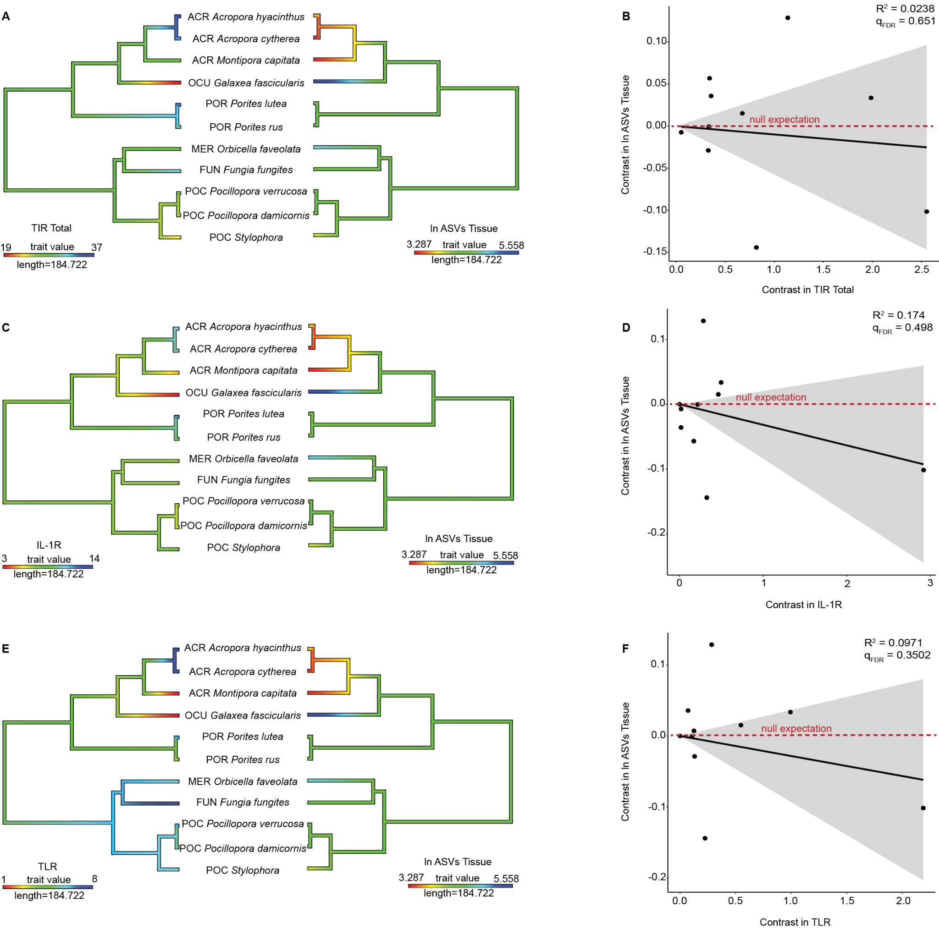

**Fig. S4. Phylogenetic comparison of coral microbiome richness and innate immune repertoire for the tissue compartment.** Rows show ancestral state reconstructions (left column) of innate immune gene copy number and microbiome richness, as well as phylogenetic independent contrast analysis for all predicted isoforms (right column) of **A,B** TIR-only genes (R2 = 0.0238, qFDR=0.929, p = 0.651); **C,D** IL-1R genes (R2 = 0.174, qFDR=0.498, p = 0.202); **E,F** TLR genes (R2 = 0.0974, qFDR=0.624, p = 0.3502) compared against log microbiome richness (ln ASVs). Shading in phylogenetic independent contrasts analysis indicates the 95% confidence interval of the mean.

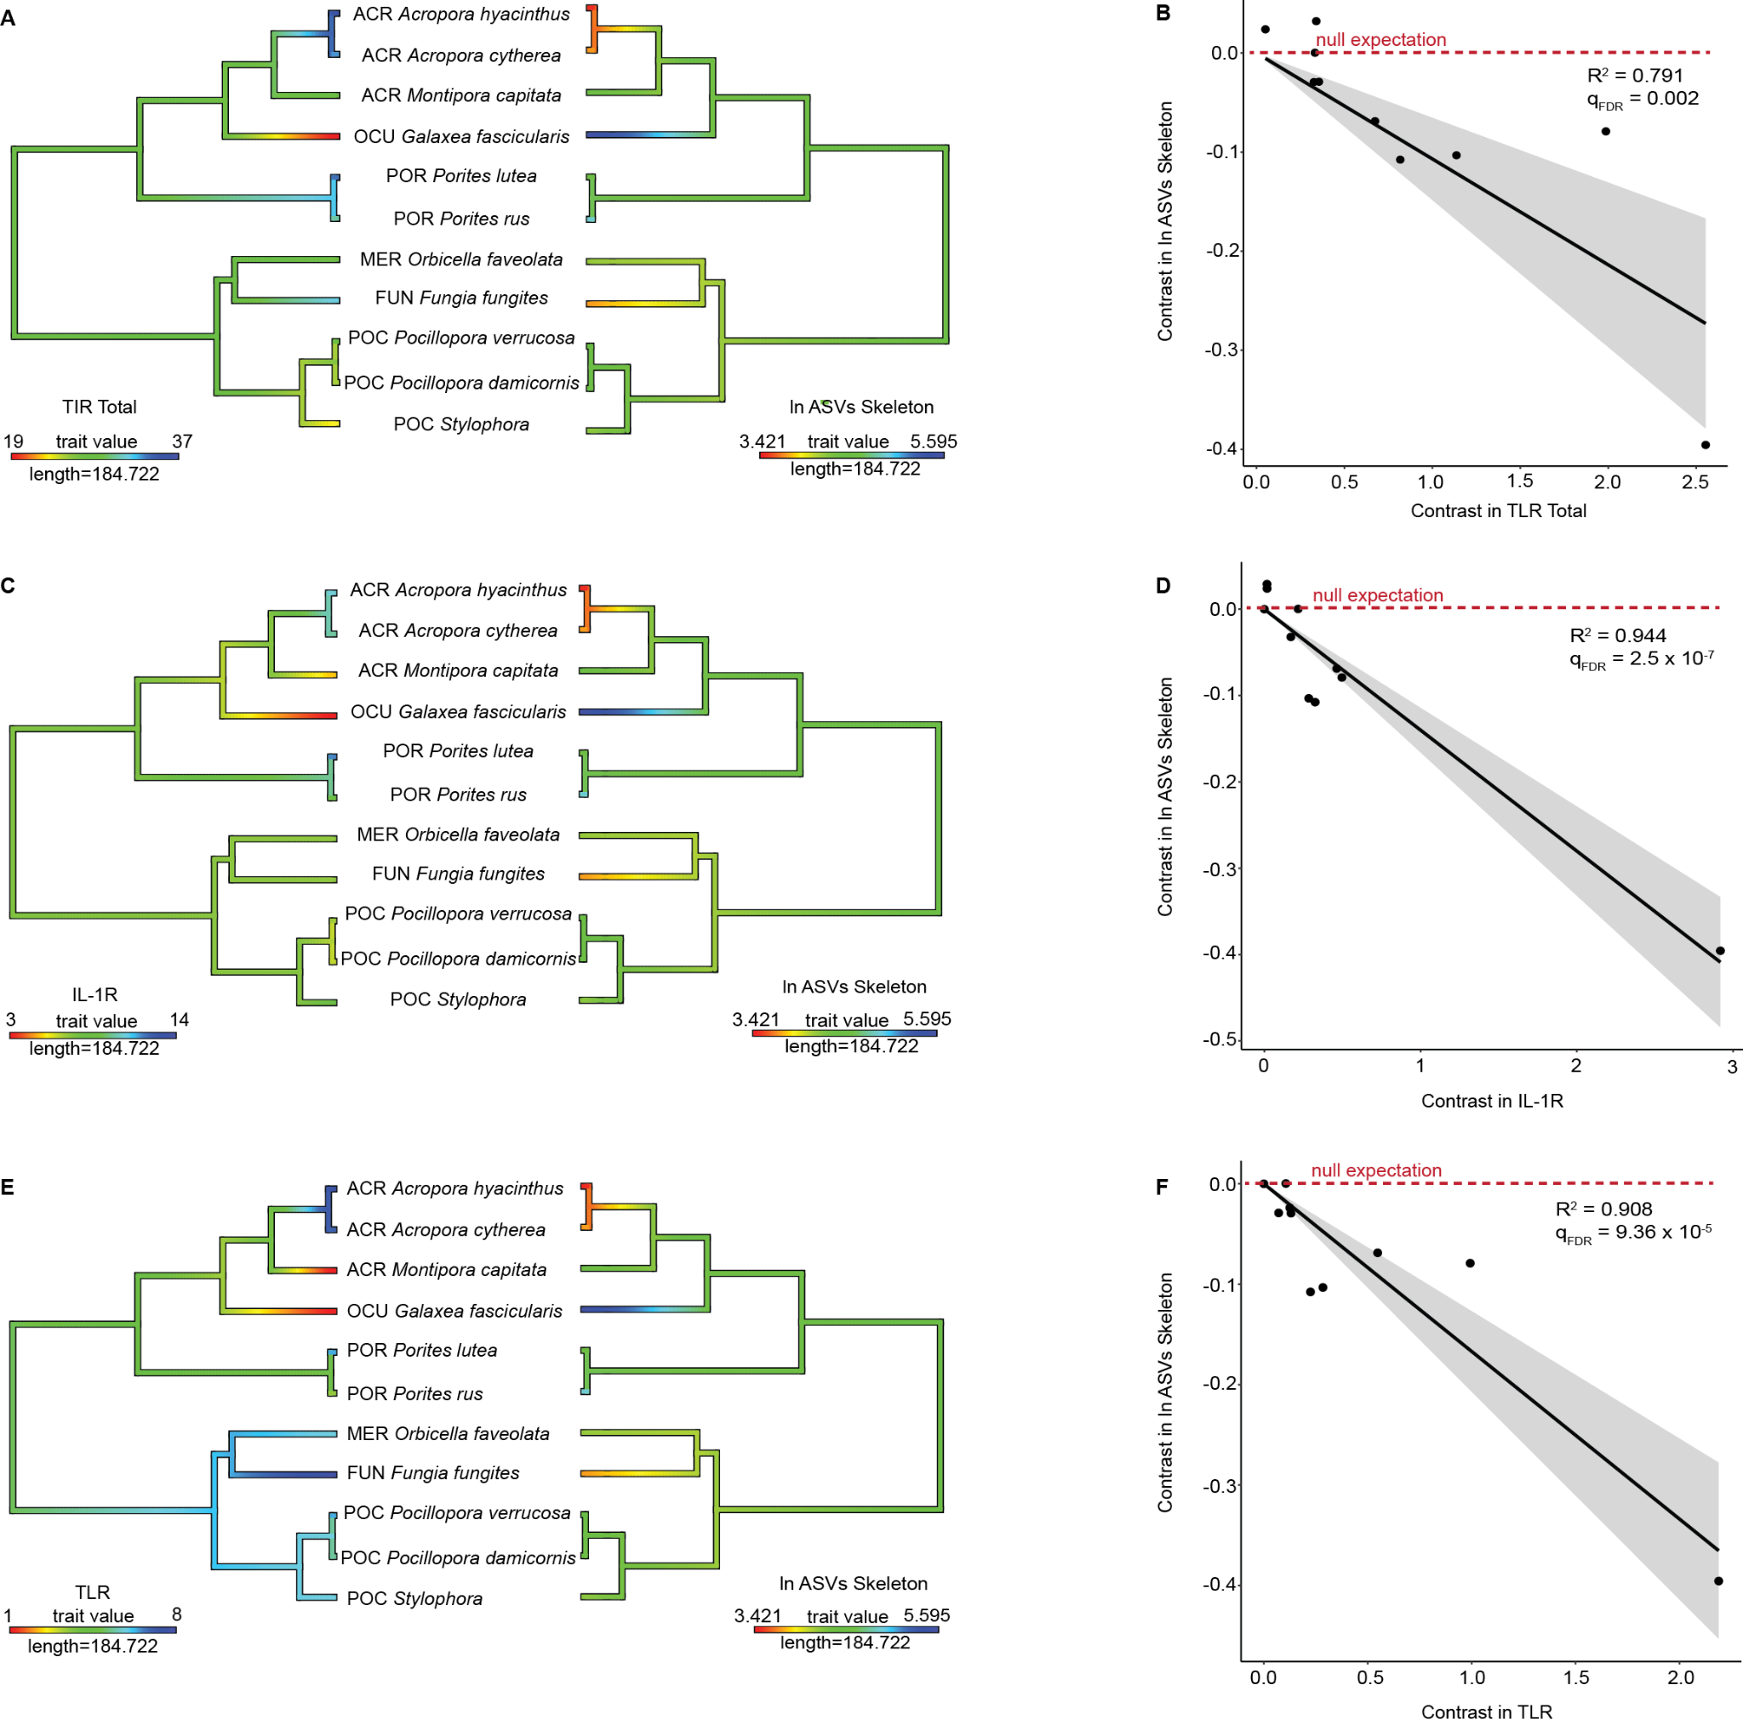

**Fig. S5. Phylogenetic comparison of coral microbiome richness and innate immune repertoire for the skeletal compartment.** Rows show ancestral state reconstructions (left column) of innate immune gene copy number and microbiome richness, as well as phylogenetic independent contrast analysis for all predicted isoforms (right column) of **A,B** TIR-only genes (R2 =0.791, qFDR=0.002, p = 0.000252); **C,D** IL-1R genes (R2 = 0.944, qFDR=2.15 x 10-5, p = 6.39 x 10-7); **E,F** TLR genes (R2 = 0.90798, qFDR= 9.36 x 10-5, p = 5.85 x 10-6) compared against log microbiome richness (ln ASVs). Shading in phylogenetic independent contrasts analysis indicates the 95% confidence interval of the mean.

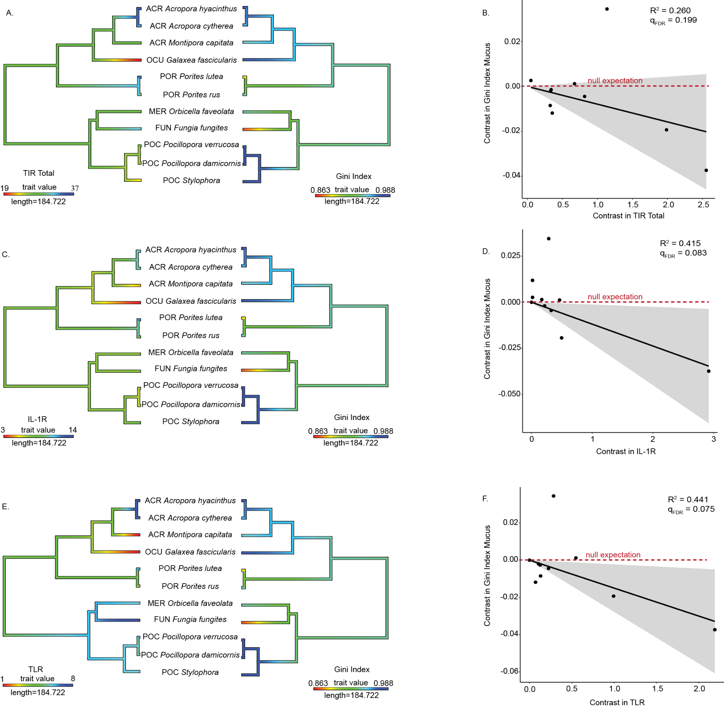

**Fig. S6**. **Phylogenetic comparison of coral microbiome evenness and innate immune repertoire in the mucus compartment.** Rows show ancestral state reconstructions (left column) of innate immune gene copy number and microbiome evenness (Gini index), as well as phylogenetic independent contrast analysis for all predicted isoforms (right column) of **A,B** TIR-only genes (R2 =0.260, qFDR=0.199, p = 0.109); **C,D** IL-1R genes (R2 = 0.415, qFDR=0.083, p = 0.0323); **E,F** TLR genes (R2 = 0.441, qFDR= 0.075, p =0.0258) compared against microbiome evenness (Gini index). Shading in phylogenetic independent contrasts analysis indicates the 95% confidence interval of the mean.

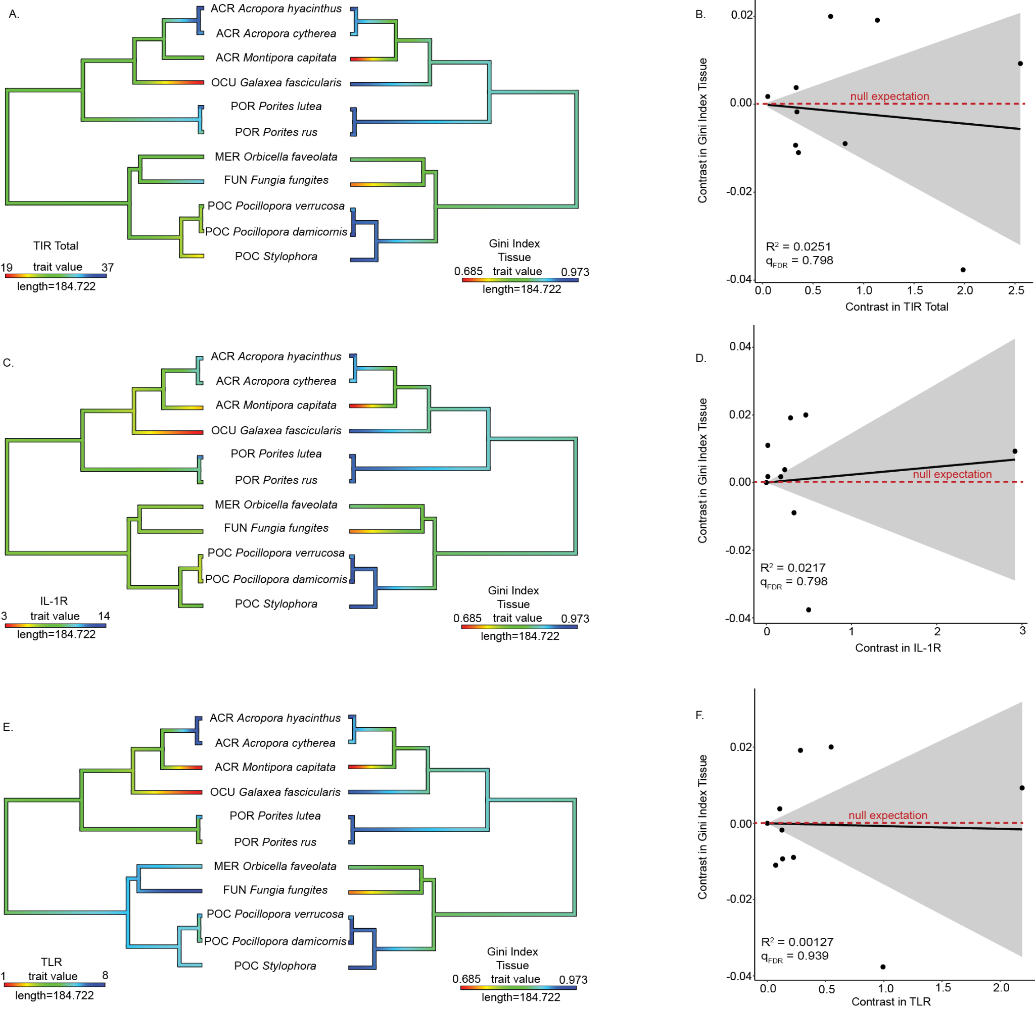

**Fig. S7**. **Phylogenetic comparison of coral microbiome evenness and innate immune repertoire in the tissue compartment.** Rows show ancestral state reconstructions (left column) of innate immune gene copy number and microbiome evenness (Gini index), as well as phylogenetic independent contrast analysis for all predicted isoforms (right column) of **A,B** TIR-only genes (R2 =0.0251, qFDR=0.798, p = 0.6421); **C,D** IL-1R genes (R2 = 0.0201, qFDR=0.798, p = 0.678); **E,F** TLR genes (R2 = 0.00127, qFDR= 0.939, p =0.917) compared against microbiome evenness (Gini index). Shading in phylogenetic independent contrasts analysis indicates the 95% confidence interval of the mean.

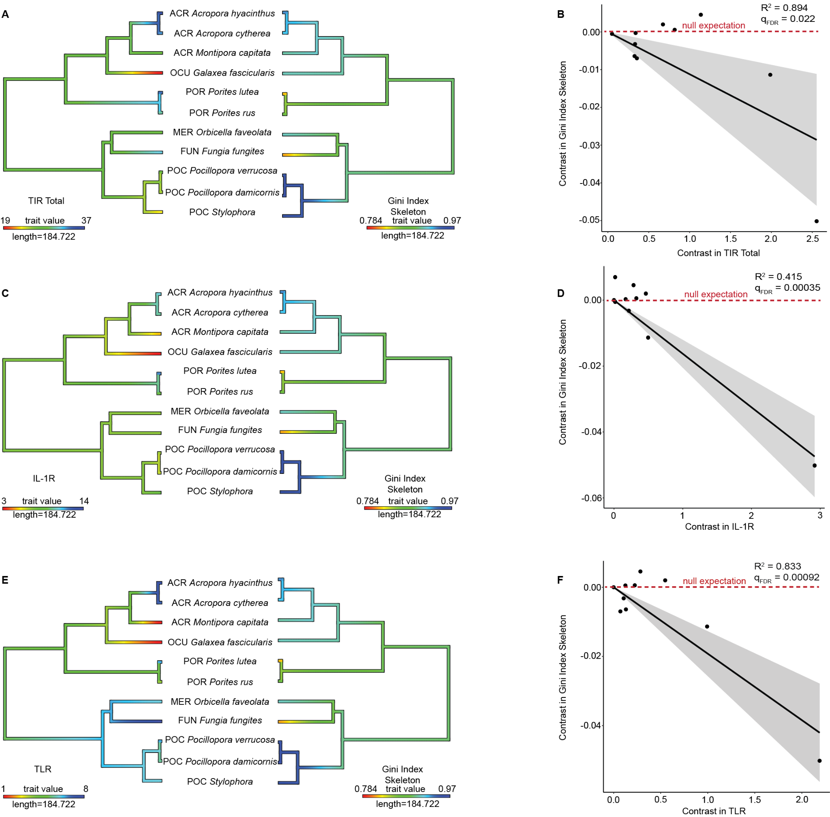

**Fig. S8**. **Phylogenetic comparison of coral microbiome evenness and innate immune repertoire in the skeleton compartment.** Rows show ancestral state reconstructions (left column) of innate immune gene copy number and microbiome evenness (Gini index), as well as phylogenetic independent contrast analysis for all predicted isoforms (right column) of **A,B** TIR-only genes (R2 =0.894, qFDR=0.022, p = 1.12 x10-5); **C,D** IL-1R genes (R2 = 0.415, qFDR=0.00035, p = 0.0323); **E,F** TLR genes (R2 = 0.833, qFDR= 0.00092, p =8.86 x 10-5) compared against microbiome evenness (Gini index). Shading in phylogenetic independent contrasts analysis indicates the 95% confidence interval of the mean.

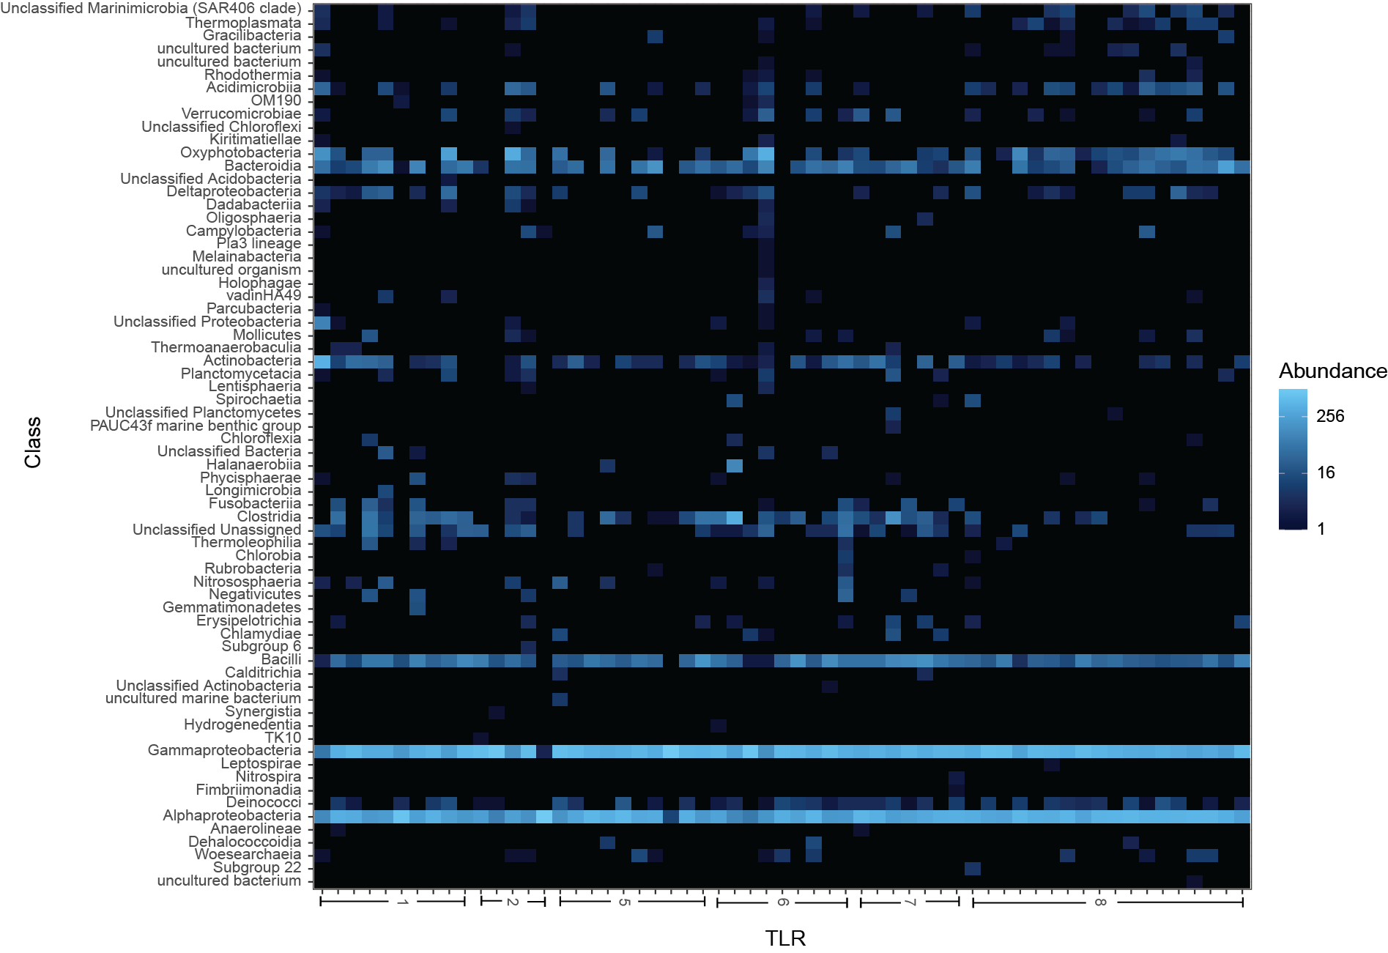

**Fig. S9****. Heatmap of bacterial class relative abundance in mucus vs. TLR gene copy number.**  Heatmap colors depict the relative abundance of bacterial classes in coral mucus (y-axis), in samples sorted by TLR gene copy number (x-axis). Colors reflect abundance per 1000 16S rRNA gene amplicon reads.

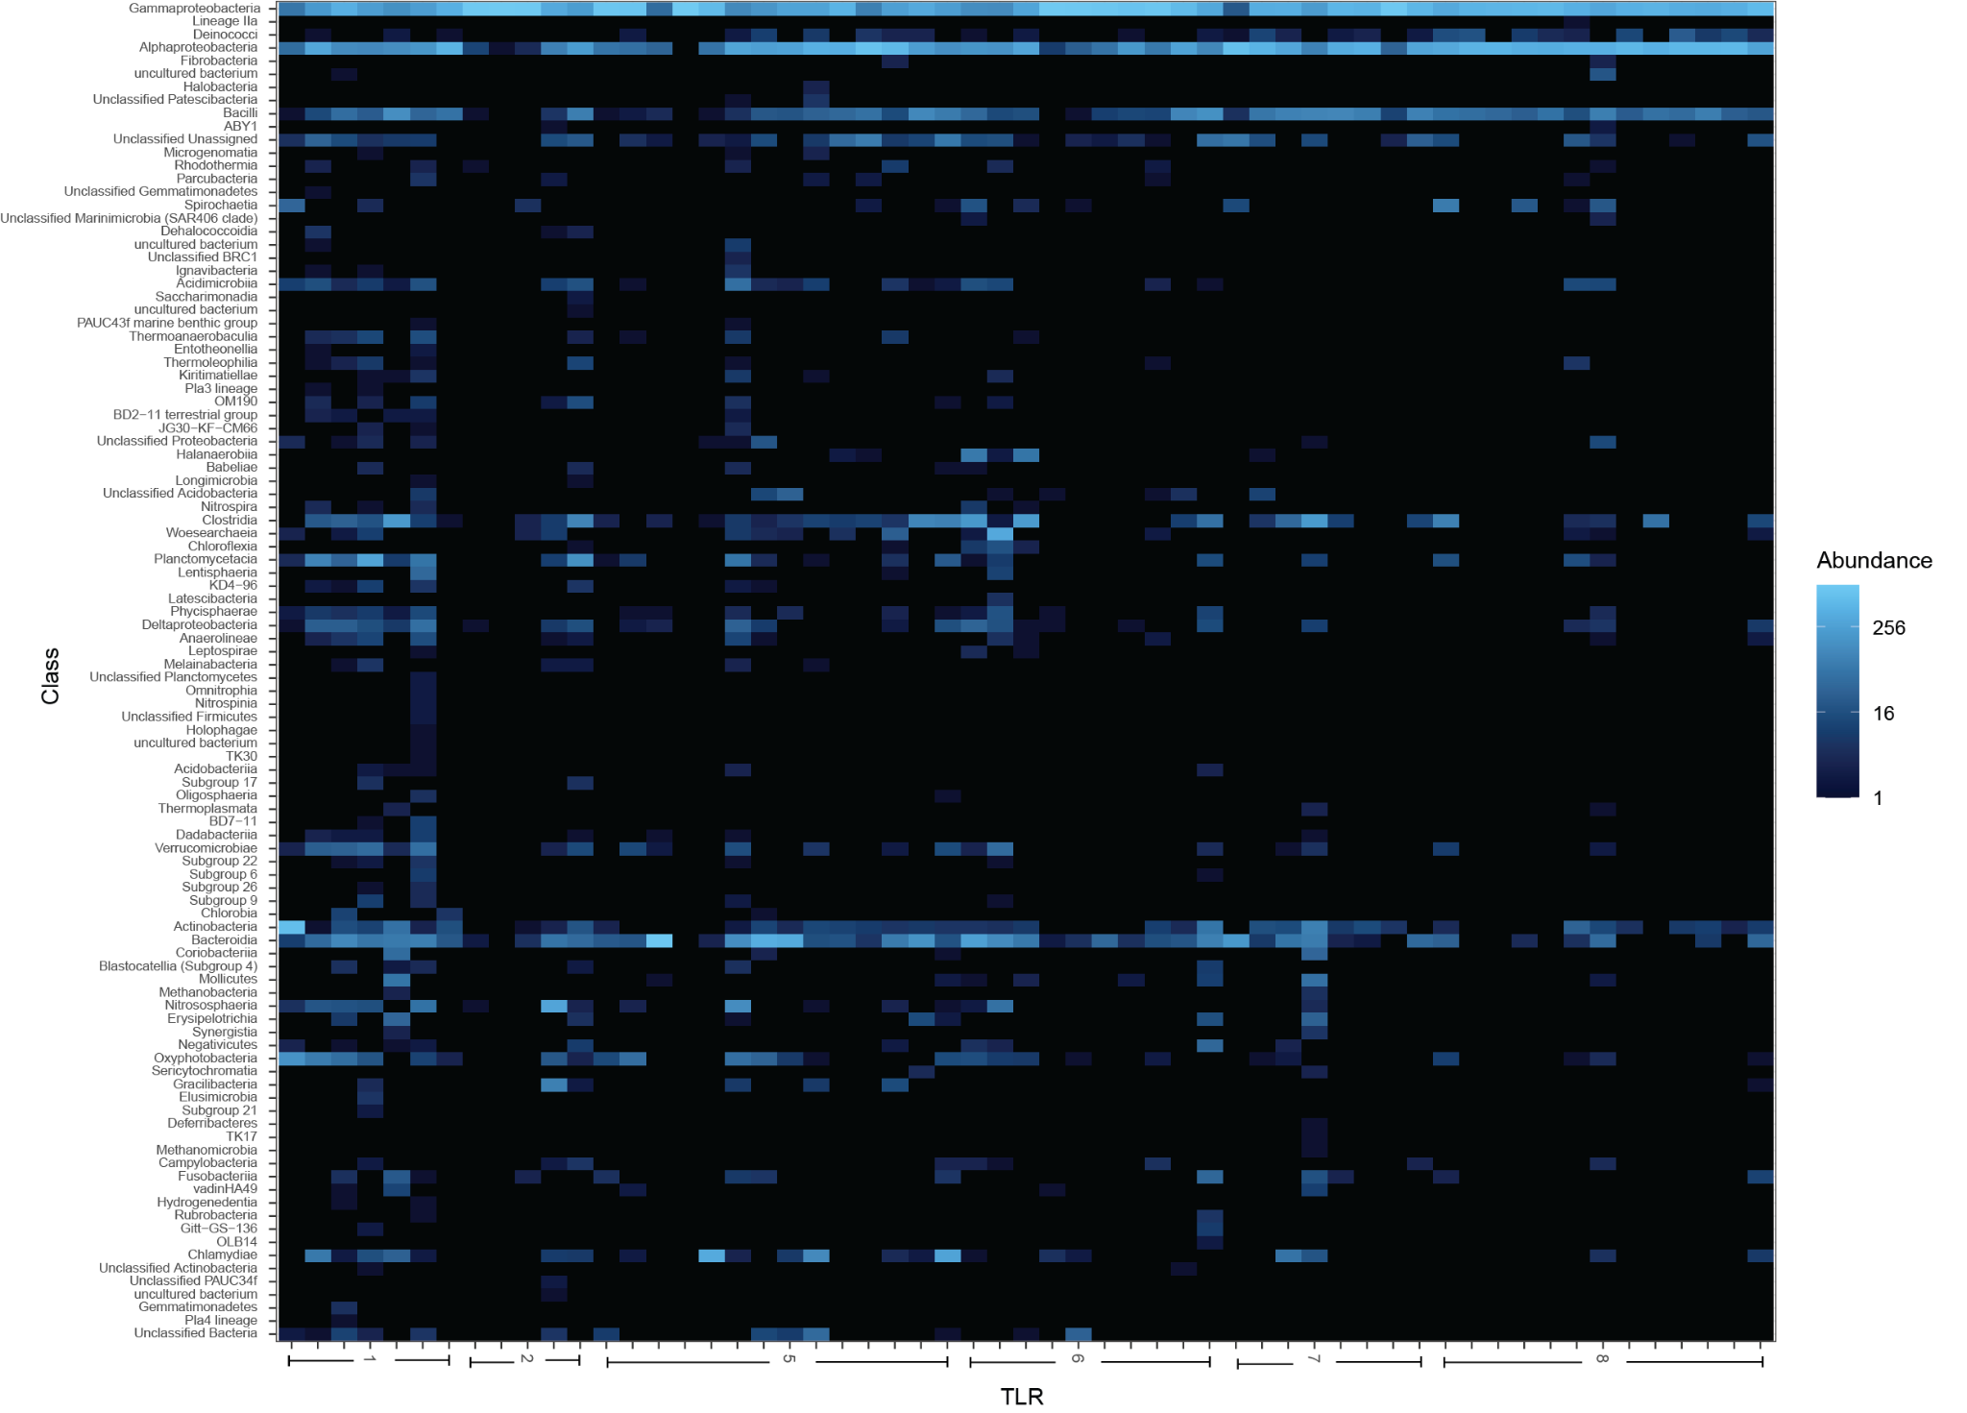

**Fig. S10****.** **Heatmap of bacterial class relative abundance in tissue vs. TLR gene copy number.** Heatmap colors depicts the relative abundance of bacterial classes in coral tissue (y-axis), in samples sorted by TLR gene copy number (x-axis). Colors reflect abundance per 1000 16S rRNA gene amplicon reads.

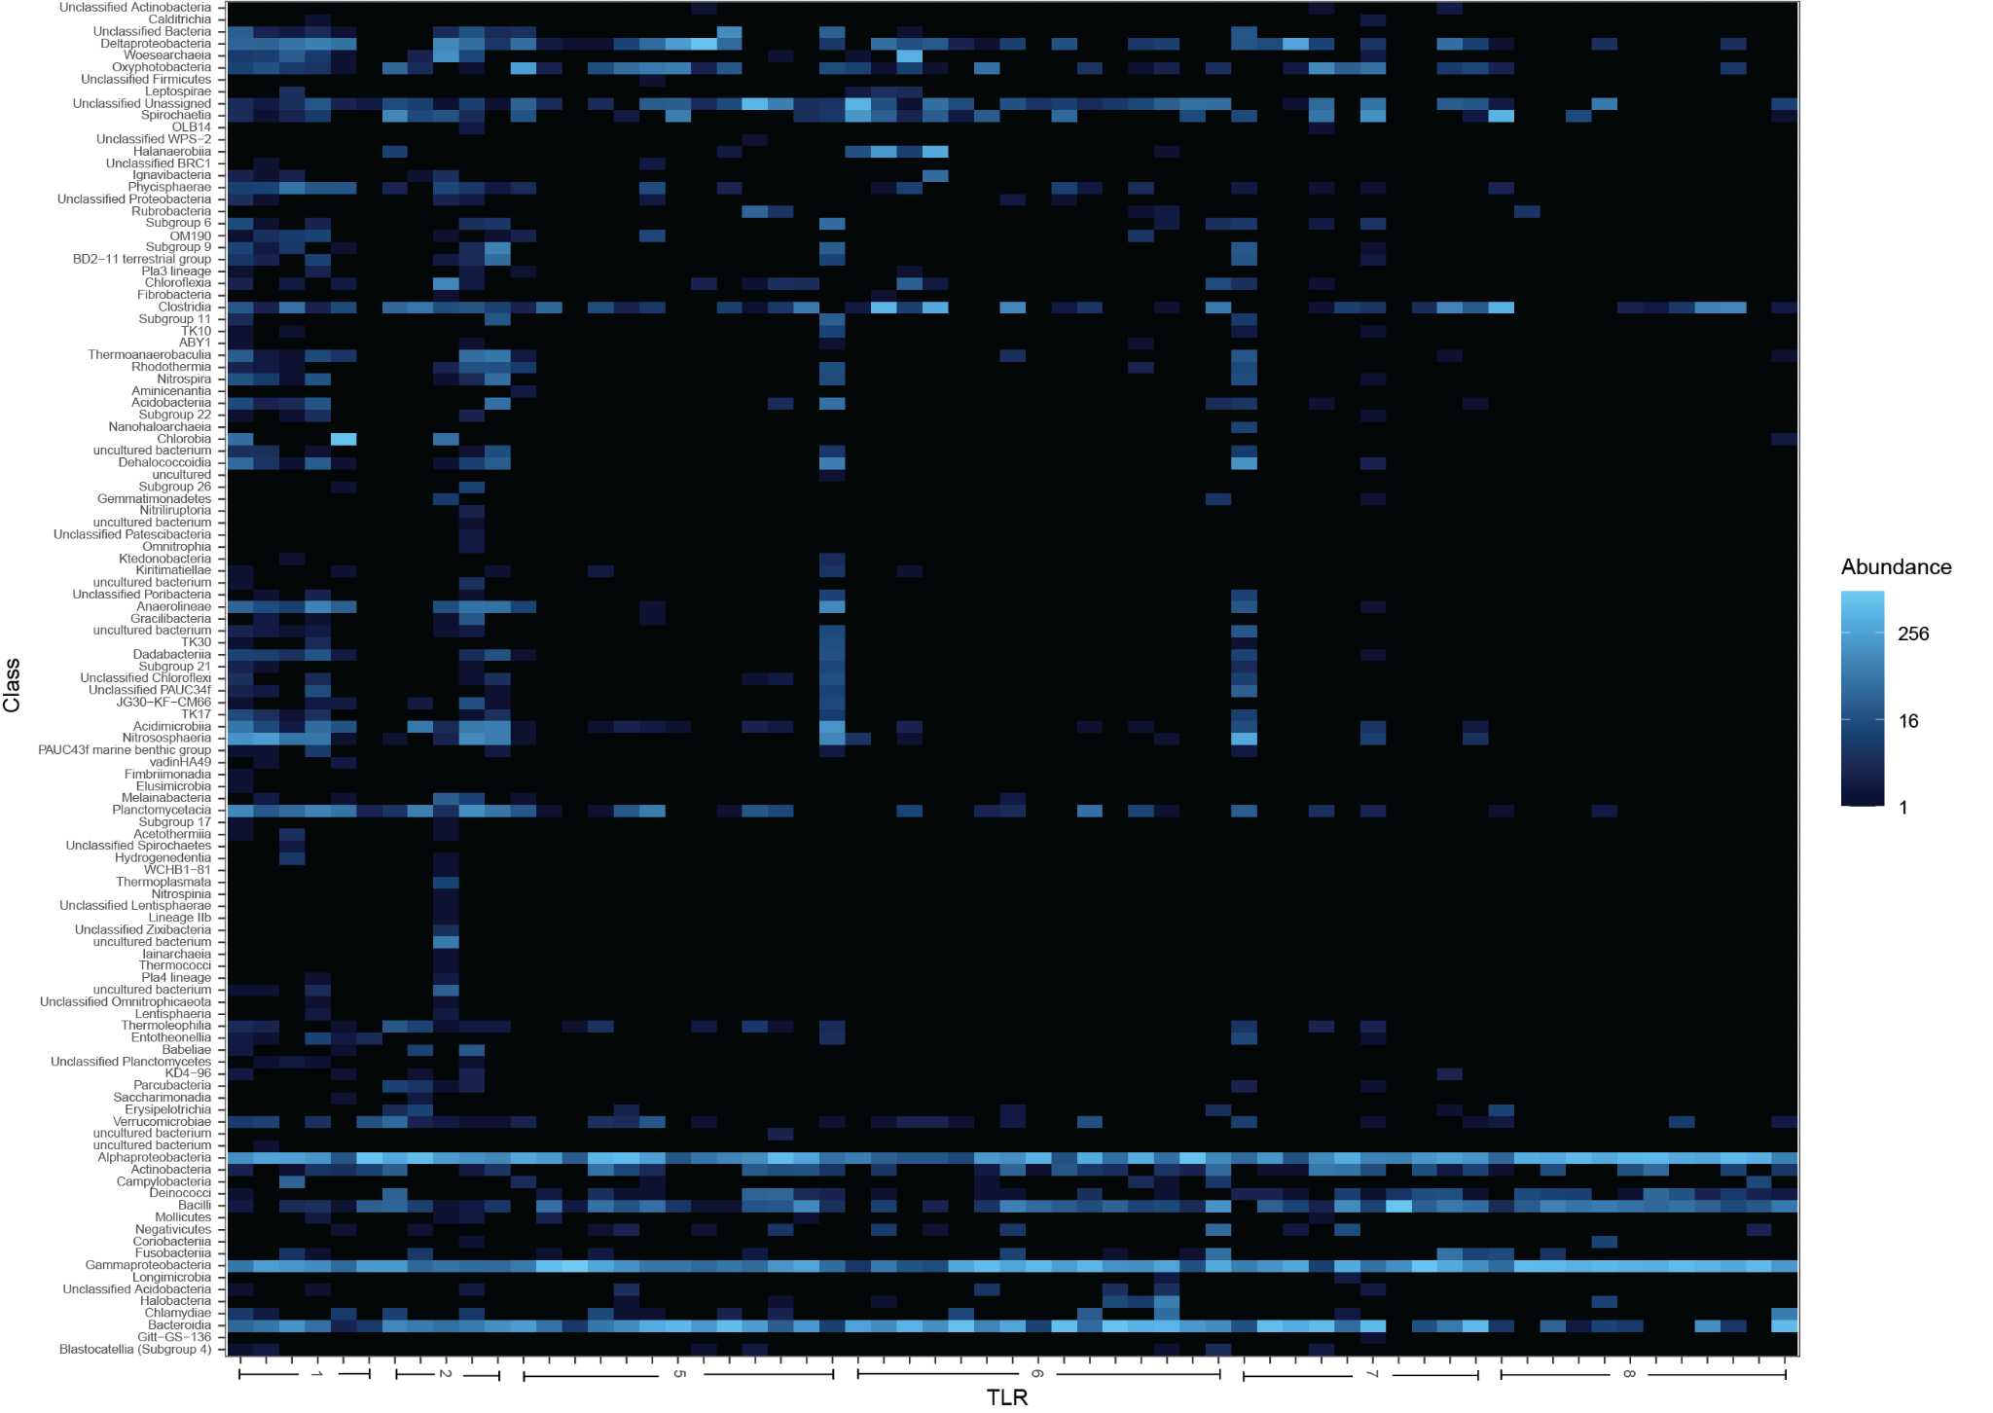

**Fig. S11.** **Heatmap of bacterial class relative abundance in skeleton vs. TLR gene copy number.** Heatmap colors depict the relative abundance of bacterial classes in coral skeleton (y-axis), in samples sorted by TLR gene copy number (x-axis). Colors reflect abundance per 1000 16S rRNA gene amplicon reads.

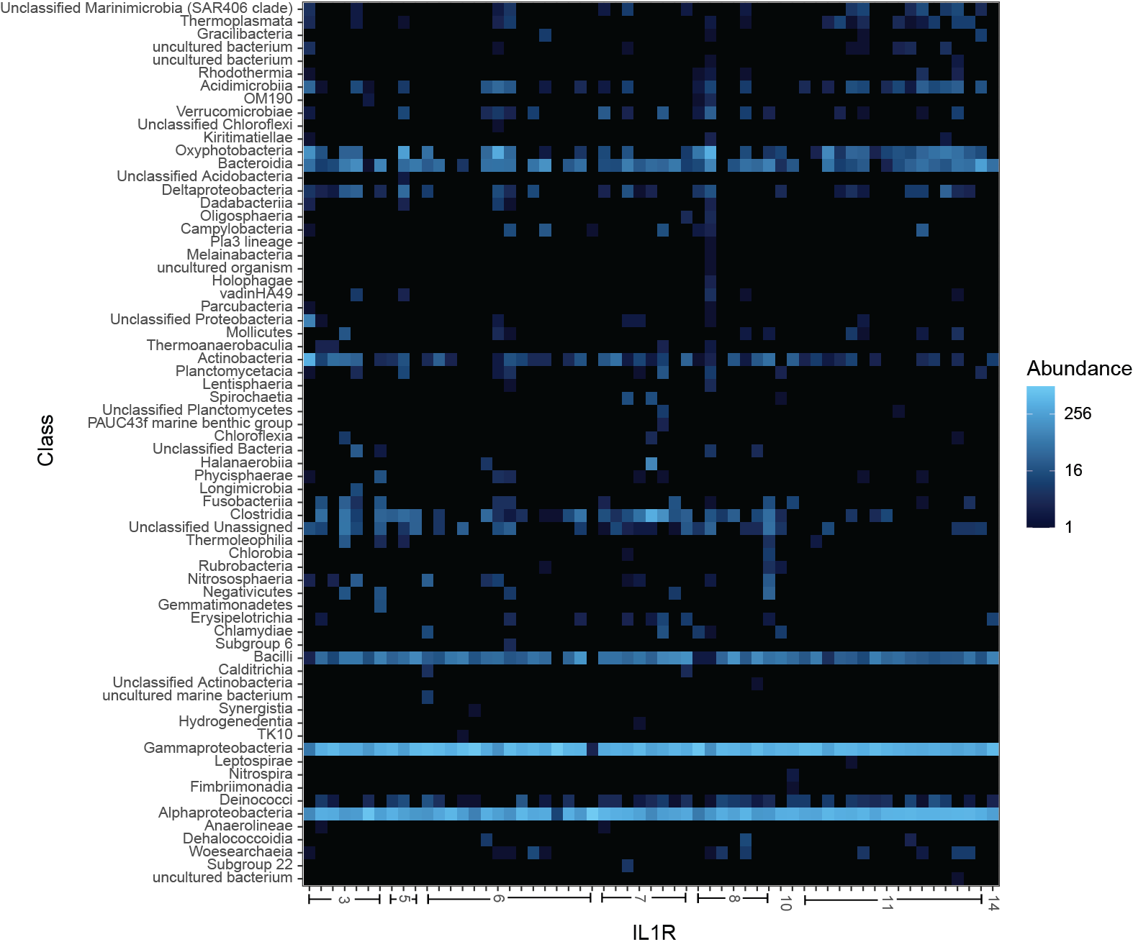

**Fig. S12. Heatmap of bacterial class relative abundance in mucus vs. IL-1R gene copy number.**  Heatmap colors depict the relative abundance of bacterial classes in coral mucus (y-axis), in samples sorted by IL-1R gene copy number (x-axis). Colors reflect abundance per 1000 16S rRNA gene amplicon reads.

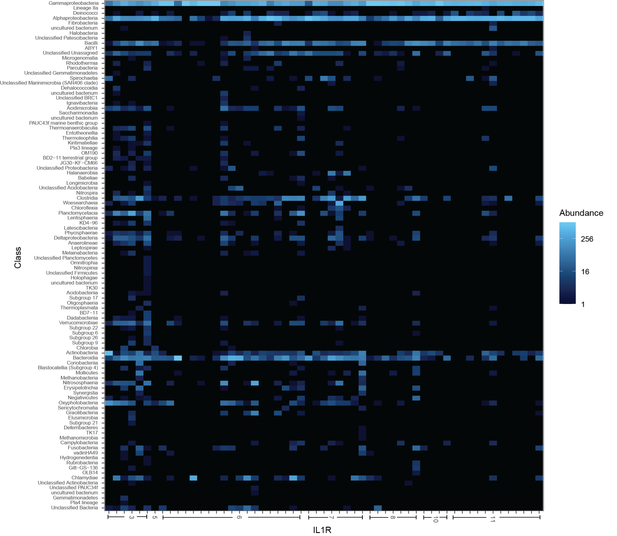

**Fig. S13.** **Heatmap of bacterial class relative abundance in tissue vs. IL-1R gene copy number.** Heatmap colors depict the relative abundance of bacterial classes in coral tissue (y-axis), in samples sorted by IL-1R gene copy number (x-axis). Colors reflect abundance per 1000 16S rRNA gene amplicon reads.

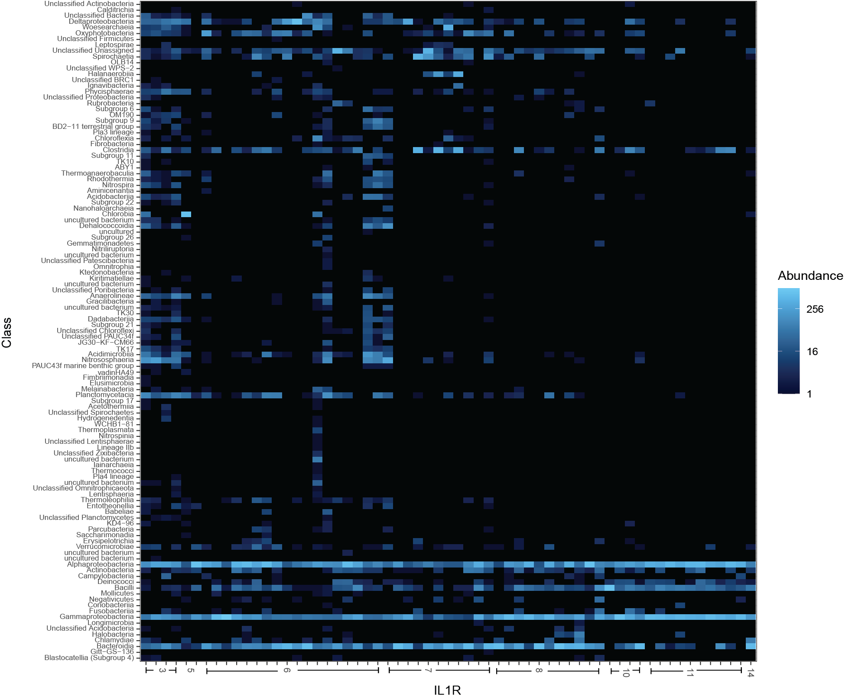

**Fig. S14.** **Heatmap of bacterial class relative abundance in skeleton vs. IL-1R gene copy number.** Heatmap colors depict the relative abundance of bacterial classes in coral skeleton (y-axis), in samples sorted by IL-1R gene copy number (x-axis). Colors reflect abundance per 1000 16S rRNA gene amplicon reads.

**15**

**6**

**Supplementary Data Tables**

**Supplementary Table 1.** Sample and Genomic metadata. (**A**) Genomes used in the analysis (B) Per sample metadata for the GCMP data (**C**) Mapping file for the GCMP data.

**Supplementary Table 2.** Annotations of TIR-domain containing gene families in coral genomes for (**A**) Total number of IL-1R and TLR genes,(**B**) Domain make up of IL-1R genes, (**C**) Domain make up of TLR genes.

**Supplementary Table 3.** Quality control information for the sequencing depth of microbiome samples in the dataset.

**Supplementary Table 4.** Distribution of TIR, LRR, and Ig domains across unique predicted protein isoforms in sequenced coral genomes.

**Supplementary Table 5.** Microbiome (**A**) richness and (**B**) evenness across samples in the analysis.

**Supplementary Table 6**. Phylogenetic comparison of IL-1R and TLR gene family copy number vs. microbiome alpha diversity in (**A**) All Samples (**B**) Mucus (**C**) Tissue, (**D**) Skeleton.

**Supplementary Table 7.** Trait table of the genomic and microbiome traits of coral species in the analysis.

**Supplementary Table 8.** Phylogenetic comparison of TIR LRR and Ig domains vs. microbiome alpha diversity in A) All Samples B) Mucus c) Tissue, d) Skeleton.

**Supplementary Table 9**. Phylogenetic comparison of IL-1R and TLR gene family copy number vs. PC axes from beta-diversity PCoA analysis in (**A**) All Samples (**B**) Mucus (**C**) Tissue, (**D**) Skeleton.

**Supplementary Table 10.** ANCOMBC comparison of relative abundance of microbial taxa vs. IL-1R and TLR gene family copy number in (**A**) All Samples (**B**) Mucus (**C**) Tissue, (**D**) Skeleton.

**Supplementary Table 11.** Phylogenetic comparison of TIR LRR and Ig domains vs. microbiome PC axes from beta-diversity PCoA analysis in (**A**) All Samples (**B**) Mucus (**C**) Tissue, (**D**) Skeleton.